**Introduction to Data Modeling**

There are two words “Data” and “Modeling”.

**Data**

What is Data, in simple word it is information in any form.

**Basic Example**

Words, numbers, pictures, symbols in particular and composition of all is data like name, age, gender, bio-data, CV, NIC, product information, home address, mobile number, family information, picture on document, email addresses, websites. Examples are not limited but for understanding all is data.

**Advance Example of Data**

What should be the advance examples of data? Simple answer is to merge multiple group of information into one become advanced form of data.

For example we have product information data in general, organization purchase these products and sale out to client is order and purchased data. To keep this whole information into one group is inventory management. Inventory management is advanced form of data. Again I tell you this is just for understanding, examples are not limited.

**Modeling**

Modeling is the process of creating a representation of a real-world system or phenomenon. This representation can be physical, mathematical, or conceptual. Models are used to understand, predict, and control systems. In simple words you will give picture to your idea.

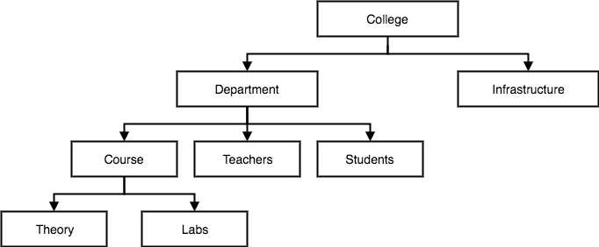

Figure shows model of school system, this is simple model picture to let you understand that what actual model look like.

Now we come to our point that elaborate in our content of chapters is What is data modeling?

**Data Modeling**

By combining these two words description from above, the resultant definition of data modeling should be given as

**“Data modeling is the process of creating a visual representation, or data model, of data objects and their relationships to one another. It is a crucial step in designing and developing databases and data warehouses, as it helps to ensure that the data is organized and stored in a way that is efficient, consistent, and easy to access and use.”**

Frankly speaking according to Bard AI this definition has been created, I will give mine as under in concise, easy and no need to open any dictionary.

**“How data kept in database tables, what are the relationship between tables, what are the columns in specified tables and its nature. To show this information in form of chart is called Data modeling”**

Simple and clear definition, in below diagram you can see columns names, table names, data types and relation between them. We will discuss in details as well.

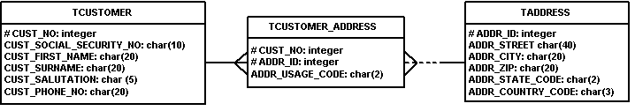

How Data kept in tables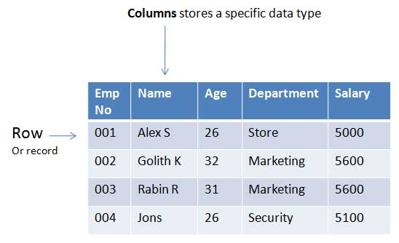

**Characteristics of Data modeling.**

1. Process of creating data model for the data to be stored in a database.
2. Data Model is conceptual representation of Database objects
3. Data Model defines the relationship between objects and rules.

**Why is data modeling important?**

Yes, Data modeling is important in all aspects if we consider database. It give graphical representation to construct best database. In real life and according to physiological theory, human understand pictures and shades in a best way.

Come up on real world importance of data modeling.

1. It is visual representation of data, we set business rules, regulatory compliances, and government policies on data.
2. We set naming convention, default values, semantics, security and quality of data.
3. An architect’s business plan which help to build conceptual business model.

**Different types of data models:-**

There are several types of data models, each with its own strengths and applications. These data models fall under three main categories:

**Conceptual**

**Logical**

**Physical**

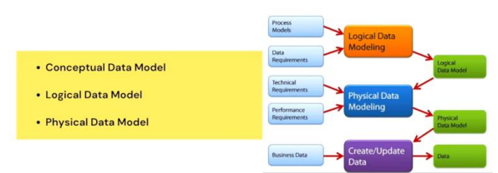

**Conceptual Data Models**

1. **Entity-Relationship (ER) Model:** The ER model is a widely used conceptual data modeling approach that represents data entities and their relationships. It involves identifying entities, attributes, and relationships between entities. (DBMS Approach)
2. **Unified Modeling Language (UML) Model:** UML is a general-purpose modeling language that can be used for conceptual data modeling. It provides a more comprehensive set of diagram types than the ER model, allowing for the representation of more complex business processes and data structures. (OOP Approach)
3. **Information Architecture (IA) Model:** IA models focus on the organization and flow of information within an organization. They help to identify and define the key information assets, their relationships, and their uses.

**Logical Data Models**

1. **Relational Model:** The relational model is the most common type of logical data model. It represents data as tables with rows and columns, and it defines relationships between tables through primary and foreign keys.
2. **Hierarchical Model:** The hierarchical model represents data as a tree structure, with parent-child relationships between data elements. It is well-suited for modeling data with a clear hierarchy, such as organizational charts or product catalogs.
3. **Network Model:** The network model is similar to the hierarchical model, but it allows for more complex relationships between data elements. It is less commonly used than the relational or hierarchical models.

**Physical Data Models**

1. **Physical Relational Model:** The physical relational model is a specific implementation of the relational model for a particular DBMS. It includes information about data types, storage requirements, and access control mechanisms.
2. **Physical Hierarchical Model:** The physical hierarchical model is a specific implementation of the hierarchical model for a particular DBMS. It includes information about storage structures and access paths for hierarchical data.
3. **Physical Network Model:** The physical network model is a specific implementation of the network model for a particular DBMS. It includes information about storage structures and access paths for network data.

The choice of data model depends on the specific requirements of the project or organization. Conceptual data models are useful for high-level planning and communication, while logical data models are more detailed and can be used to design and implement databases. Physical data models are specific to a particular DBMS and are used to implement the logical data model in the database.

**Benefits of using data models**

Data modeling is a crucial step in designing and developing databases and data warehouses. It provides a blueprint for how data should be organized and stored, ensuring consistency and efficiency in data management. Here are some of the key benefits of using data models:

1. Improved data understanding and communication: Data models provide a visual representation of data entities, attributes, and relationships, making it easier for stakeholders, including database designers, developers, and business users, to understand the structure and meaning of the data. This improved understanding facilitates better communication and collaboration during the data modeling process and throughout the data lifecycle.
2. Efficient data storage and retrieval: Data models help to optimize data storage by identifying redundancies and inconsistencies, leading to more compact and efficient data structures. Well-designed data models also facilitate efficient data retrieval by establishing clear relationships between data elements, enabling faster and more accurate queries.
3. Enhanced data consistency and integrity: Data models enforce data integrity rules and constraints, ensuring that data is consistently formatted, accurate, and complete. This helps to prevent data errors and inconsistencies that can lead to misleading results and poor decision-making.
4. Simplified data analysis and reporting: Data models provide a foundation for effective data analysis and reporting. By understanding the relationships between data elements, analysts can more easily extract meaningful insights from the data and generate comprehensive reports.
5. Adaptability to changing data needs: Data models can be adapted to accommodate changing data requirements. As business needs evolve, data models can be modified to reflect new data entities, attributes, or relationships, ensuring that the data infrastructure remains flexible and adaptable.
6. Reduced development costs and risks: Data models help to reduce development costs by providing a clear roadmap for database development. By identifying potential issues early in the design phase, data models can prevent costly rework and ensure that the database meets the organization's needs.
7. Improved data governance and security: Data models can support data governance initiatives by providing a framework for defining data ownership, access control, and usage policies. This helps to ensure that data is managed responsibly and securely throughout its lifecycle.
8. Enhanced decision-making: Data models provide a foundation for informed decision-making by enabling access to accurate, consistent, and easily understandable data. This empowers organizations to make data-driven decisions that align with business objectives and improve outcomes.

**Challenges of data modeling**

Data modeling is a crucial aspect of database design and development. However, it also presents several challenges that can impact the effectiveness and efficiency of data management. Here are some of the key challenges of data modeling:

1. Understanding data requirements: Accurately identifying and defining data requirements is essential for creating a data model that meets the needs of the organization. This can be challenging due to the evolving nature of business needs, the complexity of data relationships, and the potential for miscommunication between stakeholders.
2. Balancing normalization and denormalization: Normalization involves organizing data in a way that minimizes redundancy and inconsistencies. However, excessive normalization can lead to performance issues and complex query structures. Denormalization, on the other hand, can improve performance but may introduce data redundancy and integrity challenges. Finding the right balance between normalization and denormalization is critical for achieving optimal data organization and performance.
3. Handling data changes and evolution: Data is constantly changing, and data models need to be able to adapt to these changes. This can be challenging, as it requires identifying and implementing changes to the data model without disrupting existing applications or causing data inconsistencies.
4. Communicating and collaborating with stakeholders: Data modeling involves collaboration among various stakeholders, including database designers, developers, business users, and subject matter experts. Effective communication and collaboration are essential for ensuring that the data model aligns with business needs, meets technical requirements, and is understandable to all parties involved.
5. Choosing the right data modeling approach: There are various data modeling approaches, each with its strengths and limitations. Selecting the most appropriate approach for a particular project or organization depends on factors such as the type of data, the complexity of the data relationships, and the specific requirements of the application.
6. Ensuring data quality: Data quality is crucial for the effectiveness of data modeling and the accuracy of any insights derived from the data. Poor data quality can lead to inaccurate results, misleading conclusions, and flawed decision-making.
7. Addressing security and privacy concerns: Data modeling must consider data security and privacy implications. This involves implementing appropriate access control mechanisms, encryption techniques, and data governance policies to protect sensitive data from unauthorized access and misuse.
8. Keeping pace with technological advancements: The data landscape is constantly evolving with new technologies, data sources, and analytical tools. Data modeling needs to be adaptable and incorporate these advancements to remain effective in managing and utilizing data assets.

Overcoming these challenges requires a combination of careful planning, rigorous analysis, effective communication, and continuous improvement. By addressing these challenges, organizations can create data models that are well-structured, maintainable, and capable of supporting their data-driven initiatives.

**Best practices for data modeling**

Here are some best practices for data modeling to create a well-structured, maintainable, and effective data model:

1. Understand business requirements: Start by thoroughly understanding the business needs and objectives that the data model will support. This involves engaging with stakeholders, analyzing business processes, and identifying the key data elements that are essential for achieving business goals.
2. Define data scope and boundaries: Clearly define the scope of the data model by identifying the entities, attributes, and relationships that will be included. This helps to establish boundaries and prevent the model from becoming overly complex or encompassing irrelevant data.
3. Choose the appropriate modeling approach: Select the data modeling approach that best suits the project's requirements and the type of data being modeled. Consider factors such as the data structure, the complexity of relationships, and the specific needs of the application.
4. Normalize data effectively: Apply normalization principles to organize data in a way that minimizes redundancy and inconsistencies. This ensures data integrity and reduces the risk of errors and anomalies.
5. Identify and enforce data integrity rules: Implement data integrity rules and constraints to ensure the accuracy and consistency of data. This includes defining data types, value ranges, and referential integrity rules.
6. Document the data model: Thoroughly document the data model, including entity descriptions, attribute definitions, relationship details, and any assumptions or decisions made during the modeling process. This documentation serves as a valuable resource for developers, maintainers, and future users.
7. Review and refine the data model: Regularly review and refine the data model to ensure it remains aligned with evolving business needs and accommodates changes in data requirements. This iterative process helps to maintain the effectiveness and relevance of the data model.
8. Utilize data modeling tools: Leverage appropriate data modeling tools to streamline the modeling process, visualize data relationships, and automate routine tasks. This can improve efficiency and reduce the risk of errors.
9. Foster collaboration among stakeholders: Encourage collaboration and communication among stakeholders throughout the data modeling process. This ensures that the model meets the needs of various users and aligns with business objectives.
10. Consider data quality and governance: Implement data quality measures to ensure the accuracy and completeness of data. Establish data governance practices to manage data access, usage, and security throughout its lifecycle.
11. Stay up-to-date with technology advancements: Keep abreast of emerging technologies, data sources, and analytical tools that may impact data modeling practices. Adapt the data model and incorporate new technologies as needed to maintain effectiveness.

**Some useful snapshots**

